|  |
| --- |
| BLOOD BANK MANAGEMENT SYSTEM |
| A Final Year Project Proposal |
|  |
| **MANGESH SHRESTHA BISHAL SHRESTHA** |
| **5/2/2015** |

|  |
| --- |
| Submitted to:  **HIMALAYA COLLEGE OF ENGINEERING**    Tribhuvan University  Chysal, Lalitpur      Under the Supervision of  **Rabindra Archyra** |

**ABSTRACT**

Emergency situations, such as accidents, create an immediate, critical need for specific blood types. In addition to emergency requirements, advances in medicine have increased the need for blood in many on-going treatments and elective surgeries*.*

This paper focuses on the relevance of web based technologies in managing blood bank information with an aim to improve efficiency in this crucial process which has proven challenging in the past .

Since almost everyone carries a mobile phone with him/her, it enables to store and manage donor information and connect to receiver through Text Message(SMS) or web E-mail as a mainstream communication. The system also provide a simple remainder to staff on the blood expiry dates and blood under critical amount for more efficient management of blood bank.

1. **INTRODUCTION**

Blood Bank Management System (BBMS) is a system developed to manage blood bank based on information of donor, patient and blood. The main aim is to provide fast and efficient way to gain attention of potential donors in the need of hour .It is developed to provide an efficient of blood bank management to Blood Transfusion Unit staff of Hospital, independent agencies, non-profit foreign organization like Red Cross.

With the existence of this system, the blood bank management will become more systematic and assists in the process of blood donation.

It consists of a desktop based web application which is present to Blood Transfusion Unit staff PC of Hospital or independent organization terminals which acts as an interface for the user of the system.

In addition, the calculation of the total blood’s stock can be more accurate than the calculation is done by manually. BBMS is a system that controls the three important modules (**blood ,patient and donor**).

For **blood module**, this system manage the types, quantity and expire date for each category of blood and will come up with a simple remainder for the blood that under critical amount and expired blood .

For the **donor module**, it store the donor’s health information and this module can calculate the total of donation for each donor and display a simple reminder to give them awards.

For the **patient module**, this module stored the patient’s health information.

Notifying the donor about the need of the blood is the most important task of the system.

* 1. **PROBLEM DEFINITION**

Based on research that has been made about blood bank management in the Blood Transfusion Unit of Hospital, non-profit organization. There are some problem in managing the blood bank with existing system.

Listed below are problem faced by them.

1. Difficult to calculate amount of blood in stock.

The staff faced with problem to calculate the different stocks of blood by

manual and this situation can caused an error of calculation. The status of

blood stock also not easier to update , means sometimes the blood is not

exactly stock.

1. Unable to make a report

Before this, it was very difficult to make or get the report. It is because the

staff must manually collect information on available records.

1. Unsystematic record keeping of donors and patients

Keeping records of donors and patients are not systematically will caused to

difficulties to identify possible donor.

1. Difficulty in identify blood expiry dates.

Difficulty for staff to remember the expiry date and the amount of blood stock

for each category of blood.

These reasons motivate us to develop a more efficient system that will assist the present blood donation system.

* 1. **OBJECTIVE**

The objective of this project is to develop and deliver a new blood donation system. The system will efficiently eliminate all the problems from the present blood donation system. The system will accelerate the current process of blood donation.

It is designed to meet several objectives some of them are

* Efficient management of blood bank.
* Easy retrieval of blood based on patient and donor information.
* Reduce data redundancy so that changes information will be update consistently.
* Ensure better security in managing the blood bank.
* Ensure donors will get their awards based on the number of donation.
* Simple remainder to staff on the blood expiry dates and blood under critical amount.
* Staff can easily calculate stock of blood based on categories.
* Faster report generation based on daily or monthly information or requirements.

1. **METHODOLOGY**

We will use the waterfall methodology, which is the traditional version and the classic approach of system development life cycle. It describes the sequential and linear development method. Waterfall methodology has clear objectives and goals for each phase of the system development life cycle.

The most important steps that have been taking to build the blood bank system are:

1. **Initial phase**

* Identify the problem.
* Search for similar research, determine the objectives of each system, and then summarize it in one table.
* Determine system objective.
* Read the available literature in the form of reports and brochures.
* Determine the project plan.
* Identify the users

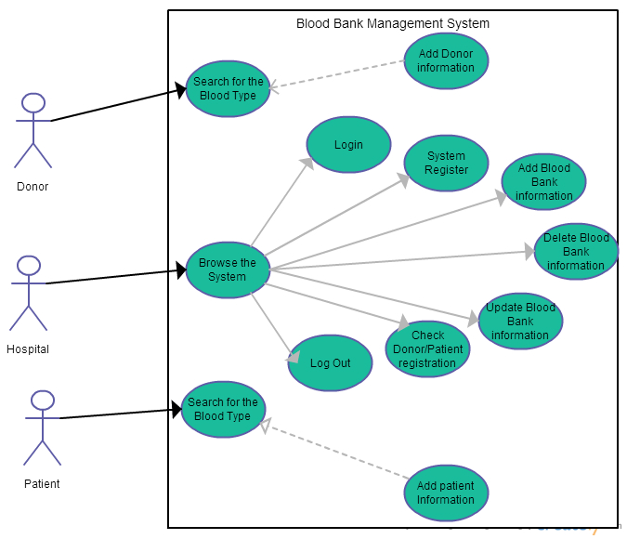

***Fig: Use Case Model for the System***

1. **Design phase**

How the system looks will be defined and prepared from the requirement.

The three designs that must be done in this stage are:

* Prototype Design
* Database Design
* User Interface Design

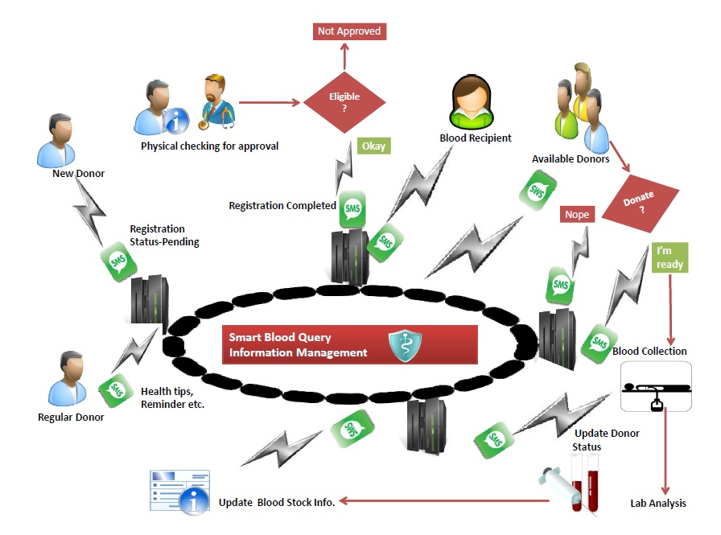

**Fig : ARCHITECTURE OF BLOOD BANK MANGEMENT SYSTEM**

1. **Implementation phase**

Implementation is the “doing” phase and help in putting all the planned activities into

and moving the project to service provision.

Languages used to implement blood band management system.

* **Java**

Java is a general purpose programming language, and is based on the object-oriented computing .It is especially suitable for developing Web application.

Our system is the desktop application. So it's platform independent meaning able to run on any OS's until java is installed on running system.

* **MySQL**: A database system, queries, and features easily paired with PHP because it works side by side with ease. Uses MSQL to store many kinds of data, information and graphics. Also it is easily accessible from anywhere in the world (Bradley, 2013).

1. **LITERATURE REVIEW**

This section explores literature review.

***3.1 NepalBloodBank.org [2005]***

Donors in Nepal who want to donate blood can register at Nepal Blood Bank after reading the basic constraints of donating blood. Nepal Blood Bank requests the donor's name, password, and ID to allow the donor to access his account, which contains information about his date of birth, blood group, gender status, weight, email ID, mobile no, city, address, and date of his last blood donation.

After that, the people who need blood can browse the

site and display the list of blood donors. NepalBloodBank.org allows recipients to search by area to have more reachable donors. The website provides the phone number to the recipients

to make contact with the donor. Also, NepalBloodBank.org provides information about

Blood Donation, such as tips, Donor message, facts, etc. It selects other blood banks for blood donation. NepalBloodBank.org offers these services for free. Further, the site doesn’t use the collected information for any commercial purposes.

(*All Rights Reserved at* *NepalBloodBank.org || All about saving lives)*

* 1. ***A Web-based blood donor MIS in Uganda [2009]***

A web-based blood Management Information System (MIS) was developed to improve the lives of the vulnerable in Uganda, besides providing adequate supply of blood. The study objectives were to develop a web based blood management system to help in the management of blood donors’ records and make it easy to distribute the blood in different parts of the country, based on each hospital’s demands.

With the use of IT technology, now relevant and timely blood donor reports easily can be generated and hence facilitate planning and decision making. It is an automated information system as a solution to routinely collected, accurate, and readily available information in blood transfusion services. It enables monitoring of the results and performance of the blood donation activity (Fredrick, 2009).

***3.3 Blood Banks Delhi in India [2003]***

It is a web-based blood bank management website that offers several services, including (Singh,

2003):

* The possibility of the donor to register online to donate blood.
* The possibility of citizens to get all the details about the donation camps.
* Help to provide blood supply for the different groups from other blood banks.
* The site has benefit for citizens by conducting all operations through online services such as registration and search for details of blood camps.

***Table 1: Comparison between Blood Bank System***

|  |  |  |  |  |
| --- | --- | --- | --- | --- |
| Name | Place | Year | Done by | Objective |
| 1. **Nepal Blood Bank** | Nepal | 2010 | Nepal Blood Bank Organization | It allows recipients to reach donors. It created a database of donors, classified by locality. Donors in Nepal who want to donate blood can register, after reading the basic constraints of donating blood. Also, anyone can refer friend(s) by just providing their email IDs. Blood recipients can browse the System and display the list of blood donors who are close to their locality. |
| 1. **A Web-based blood**   **Donor MIS** | Uganda | 2009 | Kanobe Fredrick  BA,PGDCS | It enables result and performance monitoring of each blood donation activity in a confidential, convenient, and secure way. |
| 1. **Blood Banks Delhi** | India | 2003 | XO InfoTech Ltd.  ,Gurgaon | Helps to provide blood supply of the different groups from other blood banks, provides service through online registration of blood donors, and gives news and details about blood donation events. |

1. **EVALUTION AND TESTING**

Normally, the testing and evaluation phase occurs in parallel with application programming.

We are working with a voluntary blood donor organization for testing our system. As far as the responses come till now are positive and optimistic. People who use it praise it highly as it is a

real time, faster and easily accessible system than the conventional method of contacting blood banks or blood donor organizations for blood. Furthermore, when blood banks run short of a particular blood type, the application can find several donors to refresh the supply.

After user interface of system is completed and tested regularly. Then, the data are loaded into the database, the database is tested for its performance, integrity, concurrent access, and security constraints.

The testing covers the database connectivity with the application program and the successfulness of executing the Structured Query Language (SQL) statements embedded in the application program.

1. **EXPECTED OUTPUT**

The expected output from this project is the Blood Bank Management system which has two (2) main portals, one for the public and another one for the administrator.

The public portal has the functions of displaying the blood donation events to be held and allowing the public to make online reservation.

On the other hand, the administrator portal has the functions for the administrator to manage appointments, publicize the blood donation events, manage system users, donors and blood stocks and generate reports. Besides, some automation function such as giving alert to the administrator when the blood quantity is below par level is also provided.

The kinds of reports that will be generated by the system are the blood quantity in the blood bank and workflow for each blood donation process.

The most significant results of this study are:

* Manage the records of donors, hospitals, and recipients.
* Reduce human error when employees keep the records.
* Each hospital or independent organization can register on the system and make its own account that contains information about the hospital: the blood types needed and the blood types available.
* Encourage voluntary blood donations by rewarding frequent donor.
* Make it easier for donors to find the appropriate recipients to whom to donate blood by searching in the website by blood type; a list of hospitals that need that blood type will appear.

1. **WORKING SCHEDULE**

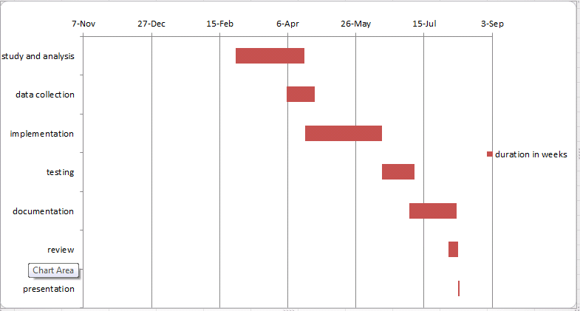

1. **REFERENCES**
2. A. Hashim, S., M. Al-Madani, A., M. Al-Amri, S., M. Al-Ghamdi, A., & S. Bashamakh. Nahla, B. (2014). Online Blood Donation Reservation And Managementsystem In Jeddah. Online Blood Donation Reservation And Managementsystem In Jeddah, 61-61
3. Sajidur Rahman, M., Asif Akter, K., Hossain, S., Basak, A., & Ishtiaque Ahmed, S. (n.d.). Smart Blood Query: A Novel Mobile Phone Based Privacy-aware Blood Donor Recruitment and Management System for Developing Regions. Smart Blood Query: A Novel Mobile Phone Based Privacy-aware Blood Donor Recruitment and Management System for Developing Regions, 4-4. Retrieved May 1, 2015, from <https://www.academia.edu/633716/Smart_Blood_Query_A_Novel_Mobile_Phone_Based_Privacy-aware_Blood_Donor_Recruitment_and_Management_System_for_Developing_Regions>
4. Gawali, A., Bhoyte, M., Lokhande, A., & Mehendale, P. (n.d.). LOCATION BASED BLOOD BANK USING CLOUD STORAGE. IJRIME, 3(2249-1619), 1-1.
5. Blood Bank Management Information System A Case Study of the Kenya National Blood Transfusion Services. (n.d.). Blood Bank Management Information System A Case Study of the Kenya National Blood Transfusion Services, 2-2.
6. ESAH, P., SAYID, B., & RAHMAN, A. (2011). BLOOD BANK MANAGEMENT SYSTEM, 5,6-5,6.
7. Blood Bank Management Information System A Case Study of the Kenya National Blood Transfusion Services. (n.d.). Blood Bank Management Information System A Case Study of the Kenya National Blood Transfusion Services, 2-2.
8. TUAN, T. G. (2006). ONLINE BLOOD DONATION RESERVATION AND MANAGEMENT SYSTEM, (2015), 20. Retrieved May 1, 2015, from <http://library.utem.edu.my/index2.php?option=com_docman&task=doc_view&gid=4279&Itemid=113> Blood Bank Donor Management. (2010).
9. Attention Required! | CloudFlare. (2010, February). Retrieved May 8, 2015, from <http://seminarprojects.com/Thread-web-based-blood-bank-management-system>
10. Alexander, A., Chacko, C., V.R, L., & Sadanandan, S. (2006). Blood Bank Management. Retrieved May 8, 2015, from <https://www.scribd.com/doc/7255868/Blood-Bank-Management>